Chapter 16, Problem 38.

The switch in the circuit of Fig. 16.61 is moved from position a to b (a make before break switch) at t = 0. Determine i(t) for t > 0.

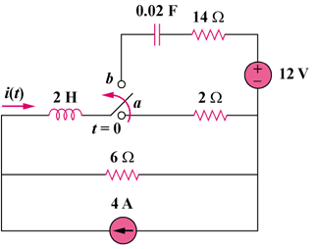

Figure 16.61
For Prob. 16.38.

